**5.5. Class tasks and assignments**

这部分内容是给今天上课了的同学完成。如果你今天没有来上课，请看下两页的安排。

Group in-class writing (小组课堂讨论活动，每个小组提交一份就好，今天中午12点前完成交给课代表，然后课代表统一交给叶老师。请利用好课堂时间有效率地和组员一起完成。)

|  |
| --- |
| Your group number ____C___ (你们小组的号码) |
| Who participated in today’s discussion: （今天参与了讨论的同学名字和他们的字母代号ABCD…）  陈雯A谢中帅B李启佳C姜庆海D高悦E李祥F朱晗霏G蒋以琳H |
| Who is submitting this group form today: Member C  今天负责提交作业的小组代表_____李启佳 C______ |
| |  | | --- | | **Final group project**  **Step 2: Find an issue under this topic (Member C)** | | * What is this issue/program?   Compared with the USA, China lags behind in the development of the core technology of the Internet of Things.   * What is doing well in this topic? What difficulties/challenges are existing?   The USA is doing well in the topic. The USA has a monopoly on the core technology of other countries, like China, Most Chinese companies are spending money on technology and doing manual labor.   * Compare this _________ issue in each region (Finish the table #1) * Find 3 sources of information (websites, books, articles, etc.)  1. Computer science newspaper 2. Technical Forums and Blogs 3. New interview media  * At least 250 words (these 250 words do NOT include the 3 sources of information) * Due by noon today   Table #1: Comparing the issue in each region   |  |  |  |  |  | | --- | --- | --- | --- | --- | | What is the issue? ___Technology development is backward, core technology is monopolized._  The existing problem is that the development of core technologies is backward, and the development of core technologies is backward. The United States is in the lead in most areas of the world, so we set the comparison goal for the United States this time. The development of the Internet of Things in China is relatively lagging behind, especially the core technology needs to be improved.  Which country/region is under comparison?___ The USA______  在中国物联网行业中找出一个问题，和其他地区国家比较，分析造成这个问题的各种原因和问题的后果 | | | | | | Comparison of angles | What are the similarities between China and the USA? | What are the differences between China and the USA? | What is surprising from the comparison? | Why? | | The influence of culture | Chinese and American cultures have realities in some aspects, such as educational culture and development culture. The exchange between countries is also very close cultural exchanges between countries pass each other and then have a certain synchronous impact on the development of the world National Internet of things problems encountered through cultural exchanges will be solved together to correct the problem. | China is a big oriental country with a history of 5000 years of civilization. The United States is only two hundred years of history, its dominant culture for European culture. Due to geographical location, historical background, development process and many other factors, there are huge differences between Chinese and American culture. So the development of the Internet of things between countries will also have a backward and an advanced normal phenomenon. | We found that culture has both advantages and disadvantages for the development of IoT between the two countries. China's core technology is lagging behind with the United States. | On the one hand, culture to a certain extent can promote the common development of the Internet of Things between countries. The other hand, too large cultural differences will also produce ambiguity in the development process, leading to the development of things stalled. | | Government and policy | It is necessary to build a system of technical standards, strengthen network security guarantees, and pay great attention to the issue of. | China promotes technological integration and innovation, first to make up for the shortcomings in all aspects as the first goal, while the United States is to continuously strengthen existing. | A comparison between China and the United States shows that China is developing much faster with the same intensity of innovation. | Because it is very difficult for the United States to further innovate on the basis of the original science and technology, China adheres to the core position of innovation in the overall situation of modernization and maintains the rapid growth of scientific and technological innovation. | | Impact on the society and citizens | The impact of the Internet of Things on society is mainly reflected in urban security and digital management. The Internet of Things is also a great help to the citizens' lives. It can make the life of the citizens more convenient. | Technological monopoly can provide national economic level and improve people's living standards. | China is still at the level of developed countries, but there is still a big gap between social and economic level and developed countries, and people's living standards are also different. | The Internet of Things has changed the management mode of the society. The impact of the Internet of Things also happens to follow the development of the information age. | | Who is suffering from this issue? | China suffers from this problem, and both China and the United States attach great importance to the emerging industry of the Internet of Things and have begun related research. | However, compared with technology, the technology of the US side is relatively high, and the relevant technical terms and materials are relatively complete, and China still needs to work hard. | Although China's research on the Internet of Things is not as good as that of the United States, China is still trying to explore, spending a lot of money and time on development and research, and the lack of core technology does not reduce China's curiosity. | Internet of Things technology can make people's lives more convenient, the rise of emerging industries is also the trend of the times, China will not encounter difficulties and retreat, on the contrary, we will face the difficulties and strive to improve their own technology. | | Other reason? | Both China and the United States are actively nurturing talent. The cultivation of talents has promoted the progress of science and technology for the country. | China's talent development tends to send people abroad to learn foreign technology, while American talent training tends to carry out technological innovation at home. | The differences in the way China and the United States cultivate make China prefer moderation, while the United States is more adventurous. Therefore, China lacks innovation on the development path of the Internet of Things. | Because Chinese education is more disciplined, while American education is more liberal. Due to the lack of innovation ability, Chinese had to send international students to learn technology abroad. | | |

**Assignment for next class:**

* Finish your **weekly reflective report**. (At least 250 words). Due **Sunday night 11:59 pm**.

Think about your final project:

* + What do you think of the group project this week? Does it help you understand your major better? Does it help you connect culture with your major?
  + How is learning English related to your major and your goals?
  + Is learning about other cultures helpful in your major and goals? Please explain.
  + At least 250 words.
  + Read the rubric closely and include the rubric in your paper

|  |  |  |
| --- | --- | --- |
| **Rubric: Weekly Journal Report (updated on April 5th, 2022)** | | |
| **Point** | **Rationale** | **Suggestions** |
| 5 | * Respond to **all** of the questions and prompts with **great details** * Little to no grammar/spelling mistakes * Author’s genuine work * Follow all of the format instructions correctly (write down the author’s name, include this rubric, at least 250 words, list the word count, paragraphs and topic sentences) | No suggestions. Continue with your good work. |
| 4 | * Respond to **some or all** of the questions and prompts with **some details** *or* * **Some** grammar/spelling mistakes *or* * Follow all of the format instructions correctly (write down the author’s name, include this rubric, at least 250 words, list the word count, paragraphs and topic sentences) | Read your essay again and consider how to add more details, correct grammar mistakes. |
| 3 | * Respond to **some or all** of the questions and prompts with **some details** *or* * **Some** grammar/spelling mistakes *or* * Did not meet some format requirements, missing the author’s name, or this rubric, or the word count or paragraphs and topic sentences | Read your essay again and consider how to add more details, correct grammar mistakes. Remember to follow the instructions. |
| 2 | * Respond to **some** of the questions and prompts with **little details** *or* * **Many** grammar/spelling mistakes (incomprehensible) * Not the author’s genuine work (work is mostly plagiarized or translated online) * Did not meet some format requirements, missing the author’s name, or this rubric, or the word count or paragraphs and topic sentences | Rewrite your essay.  Do not plagiarize work again. |
| 1-0 | * The author did minimal work, *or* * The work was totally plagiarized or the work was from online translation (the work does not reflect the author’s proficiency or voice) * Did not follow the format requirements. | Rewrite your essay. |

Important note: 因为时间冲突没有上课的同学，请完成以下内容。

**因为这个是期末考试项目，所以你们也是按照小组完成。如果你不了解如何完成小组作业，可以问课代表。**

**期末项目小组分组**

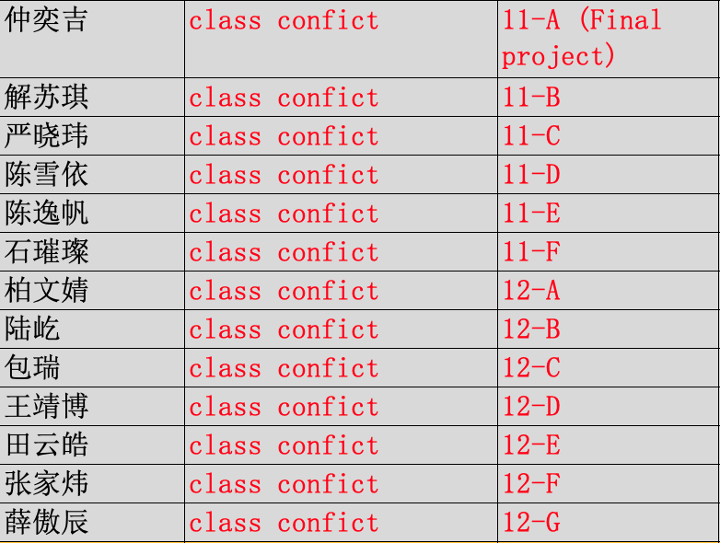

You need to submit the form to the Course Representative by **Sunday night 11:59pm**. (Don’t forget, you also need to finish weekly reflective report, that is also due Sunday night. That means, you need to submit **multiple things** to the Course Representative by Sunday night.)

|  |
| --- |
| Your group number _______ (你们小组的号码) |
| Who participated in today’s discussion: （今天参与了讨论的同学名字和他们的字母代号ABCD…） |
| Who is submitting this group form today: Member C  今天负责提交作业的小组代表名字___________  **Watch today’s recorded class, and answer the following questions:**   1. Did your team members watch the recorded class? 2. In this week’s lecture, I introduced two general purposes of writing a research paper. What are these two general purposes? |
| |  | | --- | | **Final group project**  **Step 2: Find an issue under this topic (Member C)** | | * What is this issue/program? * What is doing well in this topic? What difficulties/challenges are existing? * Compare this _________ issue in each region (Finish the table #1) * Find 3 sources of information (websites, books, articles, etc.) * At least 250 words (these 250 words do NOT include the 3 sources of information) * Due by noon today   Table #1: Comparing the issue in each region   |  |  |  |  |  | | --- | --- | --- | --- | --- | | What is the issue? ___________  Which country/region is under comparison?_________  在中国物联网行业中找出一个问题，和其他地区国家比较，分析造成这个问题的各种原因和问题的后果 | | | | | | Comparison of angles | What are the similarities between China and ______? | What are the differences between China and ______? | What is surprising from the comparison? | Why? | | The influence of culture |  |  |  |  | | Government and policy |  |  |  |  | | Impact on the society and citizens |  |  |  |  | | Who is suffering from this issue? |  |  |  |  | | Other reason? |  |  |  |  | | |

**Assignment for next class:**

* Finish your **weekly reflective report**. (At least 250 words). Due **Sunday night 11:59 pm**.

Think about your final project:

* + What do you think of the group project this week? Does it help you understand your major better? Does it help you connect culture with your major?
  + How is learning English related to your major and your goals?
  + Is learning about other cultures helpful in your major and goals? Please explain.
  + At least 250 words.
  + Read the rubric closely and include the rubric in your paper

|  |  |  |
| --- | --- | --- |
| **Rubric: Weekly Journal Report (updated on April 5th, 2022)** | | |
| **Point** | **Rationale** | **Suggestions** |
| 5 | * Respond to **all** of the questions and prompts with **great details** * Little to no grammar/spelling mistakes * Author’s genuine work * Follow all of the format instructions correctly (write down the author’s name, include this rubric, at least 250 words, list the word count, paragraphs and topic sentences) | No suggestions. Continue with your good work. |
| 4 | * Respond to **some or all** of the questions and prompts with **some details** *or* * **Some** grammar/spelling mistakes *or* * Follow all of the format instructions correctly (write down the author’s name, include this rubric, at least 250 words, list the word count, paragraphs and topic sentences) | Read your essay again and consider how to add more details, correct grammar mistakes. |
| 3 | * Respond to **some or all** of the questions and prompts with **some details** *or* * **Some** grammar/spelling mistakes *or* * Did not meet some format requirements, missing the author’s name, or this rubric, or the word count or paragraphs and topic sentences | Read your essay again and consider how to add more details, correct grammar mistakes. Remember to follow the instructions. |
| 2 | * Respond to **some** of the questions and prompts with **little details** *or* * **Many** grammar/spelling mistakes (incomprehensible) * Not the author’s genuine work (work is mostly plagiarized or translated online) * Did not meet some format requirements, missing the author’s name, or this rubric, or the word count or paragraphs and topic sentences | Rewrite your essay.  Do not plagiarize work again. |
| 1-0 | * The author did minimal work, *or* * The work was totally plagiarized or the work was from online translation (the work does not reflect the author’s proficiency or voice) * Did not follow the format requirements. | Rewrite your essay. |